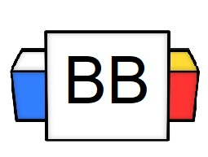 | Question: What is the most ridiculous request that you have ever made?  Answer:
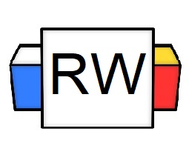 | Directions: Underline any red words that appear in the video. Fill in the blanks with whatever appears in the white text when sentences are corrected. These are keywords and concepts.  Review  Types of Sentences  There are 4 types of sentences:  - Declarative  - Interrogative  - Imperative  - Exclamatory  There are only 3 punctuation marks with which to end a sentence.  - Period.  - Question Mark?  - Exclamation Point!  Imperative Sentence  As defined, imperative is an adjective that means, “giving an authoritative command.”  An imperative sentence makes a request or demand.  It usually ends in a period; however, it can end in an exclamation point (under certain circumstances).  Example: Please take the subway.  Note: This expresses a request.  Example: I need you to run, immediately!  Note: This sentence expresses a command.  Example: Billy, go to your room!  Note: This expresses a command.  Example: Make sure you packed your didgeridoo for the camping trip.
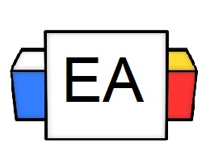 | Directions:  - In the next section, you will be given different sentences. Read each sentence and determine if it’s an example of an imperative sentence.  - Check the box for either “yes” or “no” to confirm your answer.  - Explain WHY you believe it to be a declarative sentence.  Sentence 1: Please be quiet.  Is this an example of an imperative sentence?  Yes No  Why do you believe that your answer is correct?  Sentence 2: What is your favorite breed of bird?  Is this an example of an imperative sentence?  Yes No  Why do you believe that your answer is correct?  Sentence 3: Don't eat all the bananas!  Is this an example of an imperative sentence?  Yes No  Why do you believe that your answer is correct?  Sentence 4: Why do my nightmares always become a reality?  Is this an example of an imperative sentence?  Yes No  Why do you believe that your answer is correct?  Sentence 5: Mr. Goodie Grammar looks like Jude Law lost in a canyon.  Is this an example of an imperative sentence?  Yes No  Why do you believe that your answer is correct?
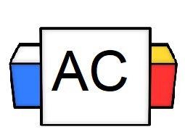 | Directions: Write two original examples of an imperative sentence.  Brainstorming Area:
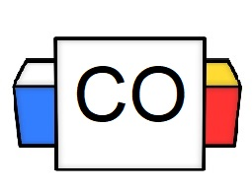 | Your Answers:  Sentence 1:  Sentence 2:
Extra Notes

