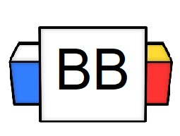 | Question: Are you a huge fan of something?  Answer:
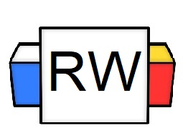 | Directions: Underline any red words that appear in the video.  What is a conjunction?  A conjunction connects words, phrases, or clauses.  What are coordinating conjunctions?  Coordinating conjunctions are the seven most basic conjunctions; they join two equal parts.  Note: They are known as F.A.N.B.O.Y.S.  F=For  A=And  N=Nor  B=But  O=Or  Y=Yet  S=So  For  “For” can be defined as “because.”  Example 1: I am so tired, for I stayed up all night to study for the math test.  And  “And” can be defined as “together with” or “as well.”  Example: The donkey and the squirrel took a trip around the world.  Example: He loves to bungee jump, and I love it too.  Nor  “Nor” can be defined as “not at all.”  Example: Neither my cat nor my puppet enjoys ice cream.  Note: Neither and Nor are correlative conjunctions together.  But  “But” can be defined as “in contrast” or “however.”  Example: Margret does not like Italian food, but she ate an entire plate of pasta.  Or  “Or” can be defined as “another alternative is.”  Example: I could go to the music festival, or I could do my homework.  Yet  “Yet” can also be defined as “in contrast.”  Example: I could go to the music festival, yet I must complete my homework.  Note: As conjunctions, “but” and “yet” are incredibly similar. They can almost be used interchangeably when used as conjunctions. However, the difference between the two comes when they change their parts of speech.  For example, “but” is a preposition, adverb, and conjunction whereas “yet” is an adverb and a conjunction. Their meanings and placements are indicative of their parts of speech.  So  “So” can be defined as “for this reason.”  Example: Henry wants to be an astronaut, so he must pay close attention to mathematical formulas.  Compound Sentence  A comma and a FANBOYS can be put between two independent clauses to form a compound sentence.  Example: Henry wants to be an astronaut, so he must pay close attention to mathematical formulas.  Important: Make sure to put the comma BEFORE  the FANBOYS when you create a compound sentence.
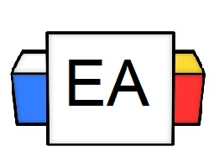 | Directions:  - In the next section, you will be given different sentences. Read each sentence and determine if it uses the correct FANBOYS.  - If not, please change it to one of the other six FANBOYS.  - Explain WHY you believe it to be correct or incorrect.  Sentence 1: He accumulated glorious wins in the coliseum, for he was strong and fearless.  Does the sentence use the correct FANBOYS?  Yes No  Why do you believe that your answer is correct?  Sentence 2: I rarely partake in interdimensional travel, but my platypus encouraged me to do it.  Does the sentence use the correct FANBOYS?  Yes No  Why do you believe that your answer is correct?  Sentence 3: Miranda could not sleep, for she listened to the ocean to calm her mind.  Does the sentence use the correct FANBOYS?  Yes No  Why do you believe that your answer is correct?  Sentence 4: Steve wants to wrangle a yeti, or he wants to swim with the Loch Ness Monster.  Does the sentence use the correct FANBOYS?  Yes No  Why do you believe that your answer is correct?  Alternative: Steve wants to wrangle a yeti, and he wants to swim with the Loch Ness Monster.  Explanation: The “or” shows that Steve wants to do option A (wrangle a yeti) OR option B (swim with the Loch Ness Monster). In the alternative option, Steven wants to do BOTH options.  Sentence 5: Dolphins love to destroy cities for make people quake in fear.  Does the sentence use the correct FANBOYS?  Yes No  Why do you believe that your answer is correct or incorrect?
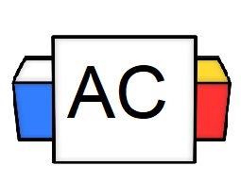 | Directions: Please write TWO original sentences that use FANBOYS.  Brainstorming Area:
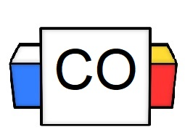 | Your Answers:  Sentence 1:  Sentence 2:
Extra Notes | Why is it essential to know FANBOYS?  It is essential to know FANBOYS because they show connections between words, phrases, and clauses. This helps with clarity and flow.

