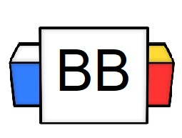 | Question: How many words are there in the English language?  Answer:
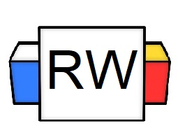 | Directions: Underline any maroon words that appear in the video. These are keywords and concepts.  Parts of Speech are categories for words and the roles they play in a sentence.  There are eight different parts of speech.  - Noun  - Pronoun  - Verb  - Adjective  - Adverb  - Preposition  - Conjunction  - Interjection  Each part of speech develops a sentence in its own particular way.  The role that it plays to develop that sentence helps determine where that word can be placed and how it will impact the sentence.  Words can also alter their part of speech depending on where they are located in the sentence.
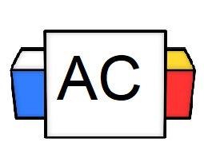 | Question: Why is it important to know the parts of speech?
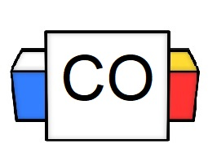 | Answer:

