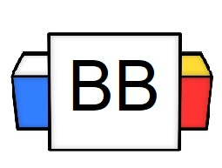 | Question: What are the characteristics of a skilled wingman/wingwoman/wingperson?  Note: These are the people who help set you up, romantically, with other people (like a matchmaker).  Answer:
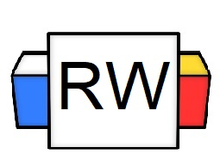 | Directions: Underline any red words that appear in the video. Fill in the blanks with whatever appears in the white text when sentences are corrected. These are keywords and concepts.  Reminder: A compound sentence is a sentence that is composed of two independent clauses joined together.  Example: Harry Potter is the superior book series, and I will not be told anything different.  What’s a semicolon?  This is a semicolon ------> ;  A semicolon is a punctuation mark that can be used to join together two independent clauses that are similar in thought.  Example:  Independent Clause 1: My dog has been training for the competition for weeks.  Independent Clause 2: I am almost certain that he is going to win.  Compound Sentence with a semicolon: My dog has been training for the competition for weeks; I am almost certain that he is going to win.  Compound Sentence with a semicolon formula  1 IDC+ (;) + 1 IDC  Note: IDC means independent clause  Example 2: There are a plethora of ice cream flavors; each flavor has its own special quality.  When you use a semicolon, you do not need to use a comma or a FANBOYS. It is strong enough on its own.  Incorrect: Batman doesn’t like Superman; so Superman doesn’t like Batman.  Correct: Batman doesn’t like Superman, so Superman doesn’t like Batman.  and  Correct: Batman doesn’t like Superman; Superman doesn’t like Batman.
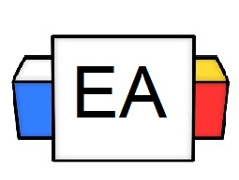 | Directions: For each compound sentence,underline the independent clauses and circle the semicolon.  Example 1: The Ouija board caused Karen to lose six pounds by possessing her; I hear it’s the trendiest new diet.  Example 2: No one came to my dance recital; everyone in my family was busy.  Example 3: I love Black Mirror; it is my favorite television show.  Incorrect Example: I love Black Mirror; the pyraminds are in Egypt.  Note: This is wrong because the two independent clauses have nothing to do with one another.
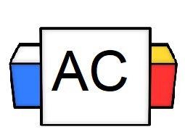 | Directions: Create an original compound sentence that joins two independent clauses with a semicolon.  Brainstorm area:
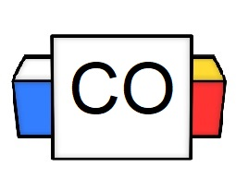 | Final Sentence:
Extra Notes

